

## QR Code Generator

MAY 2023

QR Code Generator| May 2023



QR Code Generator| May 2023

MAY 2023

BY

Sanskar Sharma

UID – 21BCS6601

CSE AIML Chandigarh University



### Meeting agenda

QR Code Generator| May 2023

Introduction to Project

# 03

MAY 2023

Problem Formulation

Objectives of the work Methodology Used Results and Outputs Conclusion

Future Scope

References

### 04 Introduction

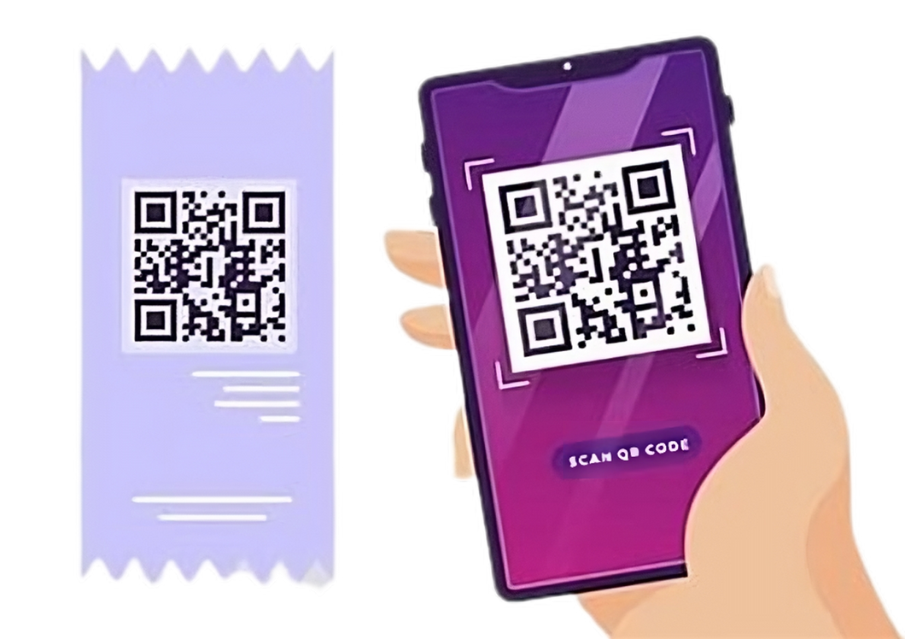

MAY 2023





**to Project**

QR stands for "Quick Response".

QR codes are two-dimensional barcodes that can be

scanned using a smartphone or other mobile device.

QR codes were first developed in 1994 by Denso Wave, a subsidiary of Toyota, as a way to track vehicles during the manufacturing process.

QR Code Generator| May 2023

QR codes can contain much more information than traditional barcodes, including website URLs, contact information, product details, and more.

QR Code Generator| MAY 2023

**Solution**

**05**

QR codes can be scanned quickly and easily using a



Traditional Barcode needs dedicated scanner.



**Needs**

smartphone

**06**

MAY 2023

**Formulation**

### Project



Traditional barcodes have **limitations** in terms of **storage capacity and versatility**, which can be a hindrance for applications requiring more complex and detailed information.

Traditional barcodes are just used for the **product identification**.

QR Code Generator| May 2023

Traditional barcodes becomes **unreadable** if they become damaged.



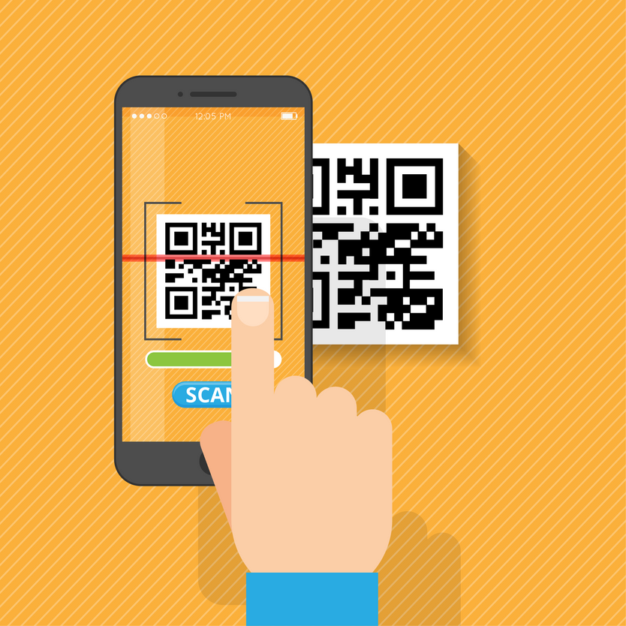Existing QR code generators often **lack user- friendliness and accessibility**, which can prevent individuals and organizations from fully utilizing the potential of QR codes.

QR Code Generator| May 2023

The problem addressed by our project is to develop a

**simple and easy-to-use** QR code generator.

Our QR code generator will overcome the limitations

# 07

MAY 2023

of traditional barcodes and provide users with a more

versatile and effective tool for creating customized codes.

Our QR code generator will be designed to meet the diverse needs of individuals and organizations, and

enable them to create customized QR codes with ease.



**08**

### Objectives of the Work

MAY 2023

Develop a **user-friendly and accessible** QR code generator that can quickly and easily generate custom codes with a variety of information types.

Implement a range of **functionality options** for the QR code generator, including color customization, different code sizes, and different data types.

Ensure the QR code generator is **compatible with different platforms** and devices, including web browsers, mobile devices, and desktop computers.

QR Code Generator| May 2023



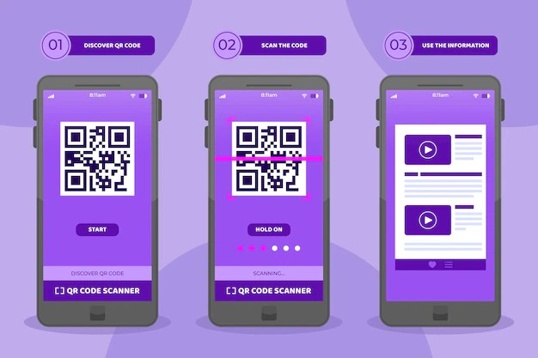Optimize the performance of the QR code generator to ensure **fast and reliable** code generation, even for large amounts of data.

QR Code Generator| May 2023

Conduct user testing and feedback sessions to ensure the QR code generator is meeting the needs of its

intended users, and **identify areas for improvement**.

Continuously update and improve the QR code **09**

MAY 2023

generator based on user feedback and emerging

trends and technologies in the field.

**10 Methodology**

MAY 2023





Import the necessary modules, such as the qr code and



thinter modules

Create the main window of the application with input

fields for text/URL, location to save the QR code, QR code name, and size

Take user inputs using input fields created with the tkinter module

Generate the QR code by encoding the user's text/URL input with the qr code module and save it to the specified location with the specified name

QR Code Generator| May 2023

Implement error handling to handle errors that may occur during the QR code generation process Thoroughly test the QR code generator with various inputs to ensure functionality and accuracy

### Used

**RESULTS AND OUTPUT**

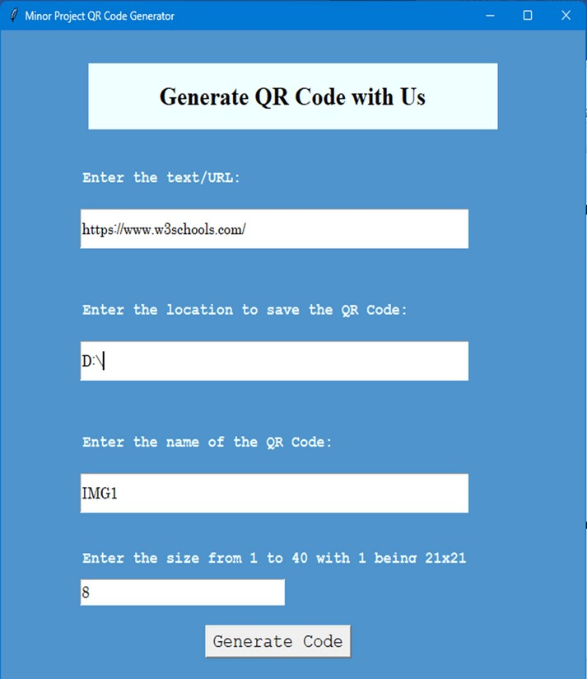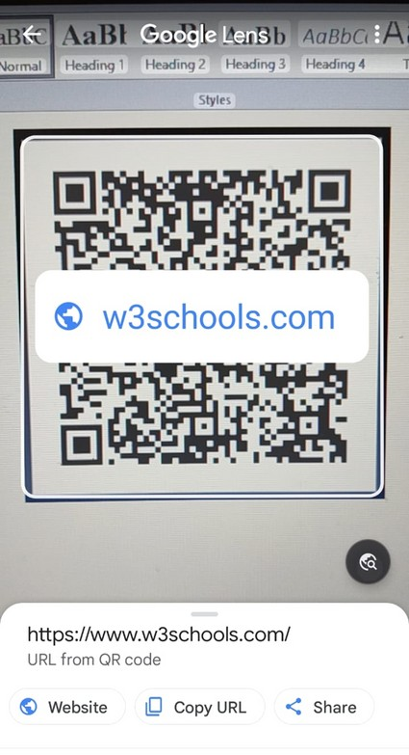

### Conclusion

QR Code Generator| May 2023

The QR code generator project successfully achieved its objectives of providing a user-friendly application to generate QR codes using Python.

By using Python and various modules such as the qr code, tkinter, the QR code generator was able to

generate accurate and high-quality QR codes.

# 12

MAY 2023

The project was able to overcome the limitations of

traditional barcodes, such as limited data storage capacity, by utilizing QR codes that can store much more information.

Further development of the QR code generator project could include additional features such as the ability to scan and read QR codes, integration with other

software, and improved error handling.

### 13 Future Scope



MAY 2023





**Integration with other software:** The QR code generator

could be integrated with other software to make it even

more user-friendly and versatile.

**Improved error handling:** The error handling in the

current version of the QR code generator could be improved to provide more detailed error messages and make the application even more user-friendly.

QR code scanning: The application could be expanded to include a QR code scanner so that users could easily read and extract information from existing QR codes.

Customizable QR codes: The application could be expanded to allow users to customize the appearance of the QR codes they generate, for example by adding a logo or changing the color scheme.

QR Code Generator| May 2023

Mobile application: The QR code generator could be developed into a mobile application.



MAY 2023

**14**QR Code Generator. (n.d.). Retrieved April 30, 2023,

**References**



from https://pypi.org/project/qrcode/

Tkinter Documentation. (n.d.). Retrieved April 30, 2023, from https://docs.python.org/3/library/tk.html Pillow Documentation. (n.d.). Retrieved April 30, 2023, from https://pillow.readthedocs.io/en/stable/ Kaur, M., & Singh, S. (2020). QR code versus barcode: A comparative study. Journal of Information Technology Management, 11(3), 36-42.

QR Code Generator| April 2023

Liao, Y., & Lu, H. (2021). A novel QR code recognition method based on edge detection and artificial neural networks. Journal of Ambient Intelligence and Humanized Computing, 12(1), 297-306.

QR Code Generator|



**Thank You**

May 2023

MAY 2023